Software Requirements Specification
for
My Bill Book
Version 1.0
Prepared by
Maveric Systems Limited
02-01-2024
Table of Contents
Table of Contents ii
Revision History ii
1. Introduction 1
1.1 Purpose 1
1.2 Document Conventions 1
1.3 Intended Audience and Reading Suggestions 1
1.4 Project Scope 1
1.5 References 1
2. Overall Description 2
2.1 Product Perspective 2
2.2 Product Features 2
2.3 User Classes and Characteristics 2
2.4 Operating Environment 2
2.5 Design and Implementation Constraints 2
2.6 User Documentation 2
2.7 Assumptions and Dependencies 3
3. System Features 3
3.1 System Feature 1 3
3.2 System Feature 2 (and so on) 4
4. External Interface Requirements 4
4.1 User Interfaces 4
4.2 Hardware Interfaces 4
4.3 Software Interfaces 4
4.4 Communications Interfaces 4
5. Other Nonfunctional Requirements 5
5.1 Performance Requirements 5
5.2 Safety Requirements 5
5.3 Security Requirements 5
5.4 Software Quality Attributes 5
6. Other Requirements 5
Appendix A: Glossary 5
Appendix B: Analysis Models 6
Appendix C: Issues List 6

Revision History
Name | Date | Reason For Changes | Version

Introduction

Purpose
The purpose of the My Bill Book e-billing website is to provide a seamless and efficient platform for businesses to generate bills for customers. The project aims to streamline the billing process, automate invoicing, enhance user experience, and ensure accuracy in financial management.

Document Conventions

1.2.1 Fonts Conventions
Throughout this document, All the user entities are written in capitalizations i.e., first letter as capital.

Intended Audience and Reading Suggestions
The purpose of this document is to give a detailed description of the requirements for the “My Bill Book” software. It will illustrate the purpose, scope and complete description for the development of system. It will also explain external interface requirements and system requirements as well as non-functional requirements.

Project Scope
My Bill Book is a e-billing website developed with the intention of automating the invoice process. It includes features such as invoicing, automated calculations, generating bill statements, customized invoice template, automate the expense process, ultimately saving time by eliminating manual errors and improving accuracy of the process.

References
<List any other documents or Web addresses to which this SRS refers. These may include user interface style guides, contracts, standards, system requirements specifications, use case documents, or a vision and scope document. Provide enough information so that the reader could access a copy of each reference, including title, author, version number, date, and source or location.>

Overall Description
This section will give an overview of the My Bill Book website. The basic functionality of the website will be explored in detail. It also describes different kinds of stakeholders and user classes associated with the system and what functionality is available for each class.

Product Perspective
This website will be an application with a simple and user-friendly GUI so that users need not have trouble accessing the application. This product serves users/ merchants for expense management by managing their bills. This product also allows them to calculate or generate the bills. Today, we all are familiar with apps and online platforms, and we prefer to do things online rather than doing it on pen and paper. Calculating the bills for users can be done easily using this application. In other ways, we have to remember bills, expenses and do manual calculations, which now can be eliminated.

Product Functionalities

User Functionalities
● Registration: User registration
● Login: Login with UserID and Password
● Forget Password: If user forgets password, then user can use this functionality to change password.
● Bill View Filter: Filter out the bills based on some constraints.
● Creating Statements: Creating Statements with filtered bills.
● Fav Bills: Creating separate section to sort out favorite bills of users.

Merchant Functionalities
● Registration: Merchant registration
● Login: Login with UserID and Password
● Forget Password: If merchant forgets password, then user can use this functionality to change password.
● Creating or selecting templates: Customized invoice templates
● Creating Bills: Generate bills for users
● Customer Bill Details: Can view the customer’s bills.
● Bill View Filter: Filter out the bills based on some constraints.
● Bill Statements: Creating Statements with filtered bills.
● Bill Printouts: Hard copy of bills.

User Classes and Characteristics
There are two types of users that interact with our system. Firstly, there is a user and merchant. We’ll provide an interface for Users to view all the bill details. Another interface is for merchants to select a template and create a bill, but they cannot change internal functionalities.

User Class
Users can login into our system and interact with our system directly in order to get or view the bills. They can filter out bills based on categories like food, travel, miscellaneous and can sort the bills based on time and price.

Merchant Class
Merchant can login into our system and interact with our system directly in order to create or view the bills. They can select the custom template to create the bill, or they can just directly add their own bill. They can filter the bills based on customer details.

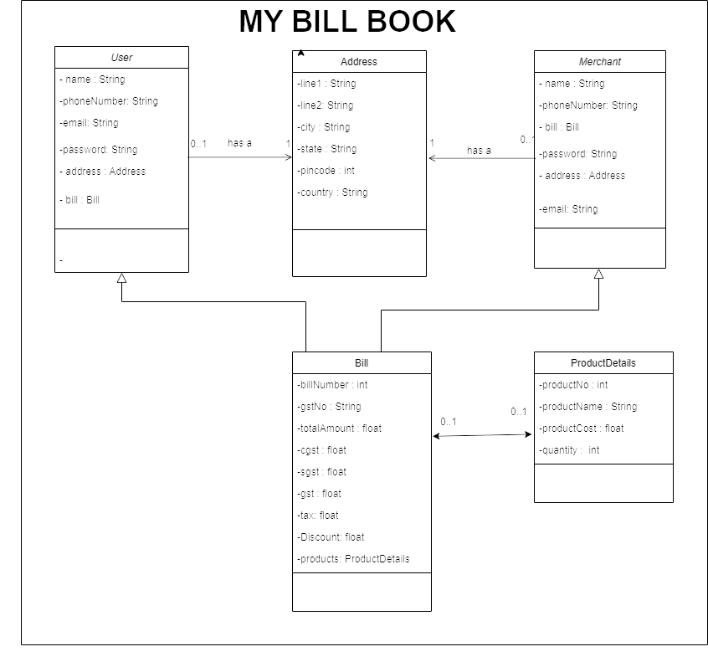

Operating Environment
It is a website running on an any browser in any device like mobiles and pcs. Firstly, when a user logs in with the credentials, he can view the dashboard where he can view or edit his profile, view the bills, and can print the bills. For merchant, when he login with credentials he can view the dashboard where he can choose a template to create a bill or add the bill directly, he can also view the bills of his customers.

Design and Implementation Constraints

Operating System Constraints
The system should be compatible and will smoothly run on any browser.

Device Constraints
My Bill Book system and its user interfaces should be compatible with any device with browser.

User Documentation
<List the user documentation components (such as user manuals, on-line help, and tutorials) that will be delivered along with the software. Identify any known user documentation delivery formats or standards.>

Assumptions and Dependencies
<List any assumed factors (as opposed to known facts) that could affect the requirements stated in the SRS. These could include third-party or commercial components that you plan to use, issues around the development or operating environment, or constraints. The project could be affected if these assumptions are incorrect, are not shared, or change. Also identify any dependencies the project has on external factors, such as software components that you intend to reuse from another project, unless they are already documented elsewhere (for example, in the vision and scope document or the project plan).>

Specific Requirements

Functional Requirements: User
F1: This website shall allow users to register with their Mobile number.
F2: This website shall allow users to login with their UserID and password.
F3: This website shall allow users to change their password in case user forget.
F4: This website shall allow users to access their dashboard and view bills.
F5: This website shall allow users to filter bills based on constraints.
F6: This website shall allow users to create the statement for the filtered bills.
F7: This website shall allow users to download their desired bills.
F8: This website shall allow users to mark their bills as favorite.

Use Case Model : User 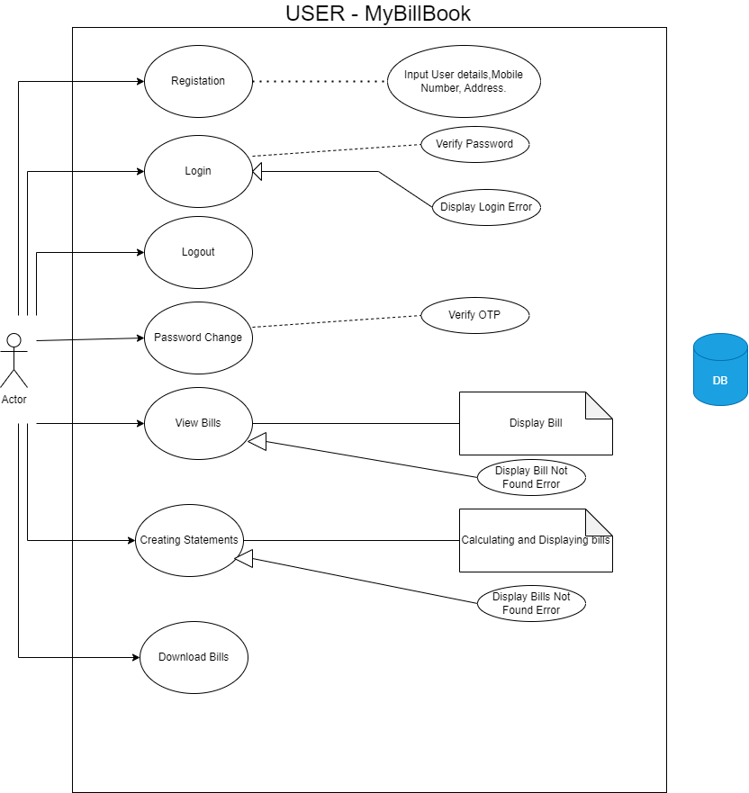

Use Case #1 (Registration)
Purpose - To register users with mobile number to use the website.
Requirements Traceability – F1
Actors – User

Use Case #2 (Login)
Purpose – To allow users to login with UserID and password.
Requirements Traceability – F2
Actors – User

Use Case #3 (Password Change)
Purpose – To allow users to change the password if he want to or forget the password.
Requirements Traceability – F3
Actors – User

Use Case #4 (View Bills)
Purpose – To allow users to access the dashboard and view the bills.
Requirements Traceability – F4
Actors – User

Use Case #5 (Filter Bills)
Purpose – To allow users to filter bills based on constraints.
Requirements Traceability – F5
Actors – User

Use Case #6 (Creating Statements)
Purpose – To allow users to create the statement for the filtered bills.
Requirements Traceability – F6
Actors – User

Use Case #7 (Download Bills)
Purpose – To allow users to download their desired bills.
Requirements Traceability – F7
Actors – User

Use Case #8 (Favorite Bills)
Purpose – To allow users to mark their bills as favorite.
Requirements Traceability – F8
Actors – User

3.3 Functional Requirements: Merchant
F1: This website shall allow merchants to register with Mobile number.
F2: This website shall allow merchants to login with their UserID and password.
F3: This website shall allow merchants to change their password in case merchant forget.
F4: This website shall allow merchants to select a template to create the bill or to add their own.
F5: This website shall allow merchants to create the statements with customer details.

Use Case Model: Merchant
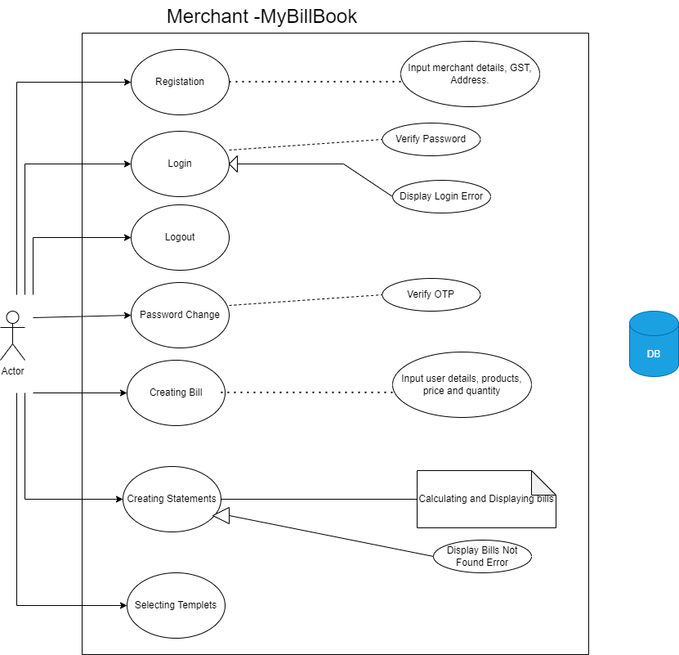

Use Case #1 (Registration)
Purpose – To allow merchants to register with mobile number.
Requirements Traceability – F1
Actors – Merchant

Use Case #2 (Login)
Purpose – To allow merchants to login with UserID and password.
Requirements Traceability – F2
Actors – Merchant

Use Case #3 (Password Change)
Purpose – To allow merchants to change the password if he want to or forget the password.
Requirements Traceability – F3
Actors – Merchant

Use Case #4 (Create Template)
Purpose – To allow merchants to select a template to create the bill or to add their own.
Requirements Traceability – F4
Actors – Merchant

Use Case #5 (Create Statement)
Purpose – To allow merchants to create the statements with customer details.
Requirements Traceability – F5
Actors – Merchant

External Interface Requirements

User Interfaces
<Describe the logical characteristics of each interface between the software product and the users. This may include sample screen images, any GUI standards or product family style guides that are to be followed, screen layout constraints, standard buttons and functions (e.g., help) that will appear on every screen, keyboard shortcuts, error message display standards, and so on. Define the software components for which a user interface is needed. Details of the user interface design should be documented in a separate user interface specification.>

Hardware Interfaces

Software Interfaces
<Describe the connections between this product and other specific software components (name and version), including databases, operating systems, tools, libraries, and integrated commercial components. Identify the data items or messages coming into the system and going out and describe the purpose of each. Describe the services needed and the nature of communications. Refer to documents that describe detailed application programming interface protocols. Identify data that will be shared across software components. If the data sharing mechanism must be implemented in a specific way (for example, use of a global data area in a multitasking operating system), specify this as an implementation constraint.>

Communications Interfaces
<Describe the requirements associated with any communications functions required by this product, including e-mail, web browser, network server communications protocols, electronic forms, and so on. Define any pertinent message formatting. Identify any communication standards that will be used, such as FTP or HTTP. Specify any communication security or encryption issues, data transfer rates, and synchronization mechanisms.>

Other Nonfunctional Requirements

Performance Requirements
<If there are performance requirements for the product under various circumstances, state them here and explain their rationale, to help the developers understand the intent and make suitable design choices. Specify the timing relationships for real time systems. Make such requirements as specific as possible. You may need to state performance requirements for individual functional requirements or features.>

Safety Requirements
<Specify those requirements that are concerned with possible loss, damage, or harm that could result from the use of the product. Define any safeguards or actions that must be taken, as well as actions that must be prevented. Refer to any external policies or regulations that state safety issues that affect the product’s design or use. Define any safety certifications that must be satisfied.>

Security Requirements
<Specify any requirements regarding security or privacy issues surrounding use of the product or protection of the data used or created by the product. Define any user identity authentication requirements. Refer to any external policies or regulations containing security issues that affect the product. Define any security or privacy certifications that must be satisfied.>

Software Quality Attributes
<Specify any additional quality characteristics for the product that will be important to either the customers or the developers. Some to consider are: adaptability, availability, correctness, flexibility, interoperability, maintainability, portability, reliability, reusability, robustness, testability, and usability. Write these to be specific, quantitative, and verifiable when possible. At the least, clarify the relative preferences for various attributes, such as ease of use over ease of learning.>

Other Requirements

<Define any other requirements not covered elsewhere in the SRS. This might include database requirements, internationalization requirements, legal requirements, reuse objectives for the project, and so on. Add any new sections that are pertinent to the project.>
Appendix A: Glossary
<Define all the terms necessary to properly interpret the SRS, including acronyms and abbreviations. You may wish to build a separate glossary that spans multiple projects or the entire organization, and just include terms specific to a single project in each SRS.>
Appendix B: Analysis Models
<Optionally, include any pertinent analysis models, such as data flow diagrams, class diagrams, state-transition diagrams, or entity-relationship diagrams.>
Appendix C: Issues List
< This is a dynamic list of the open requirements issues that remain to be resolved, including TBDs, pend
ing decisions, information that is needed, conflicts awaiting resolution, and the like.>

